Directions: List which hand tool category to which it belongs and which specific tool it is most like. Then list the similarities between it and its match as well as list differences between it and the remaining tools, in the chosen category, it is not like.
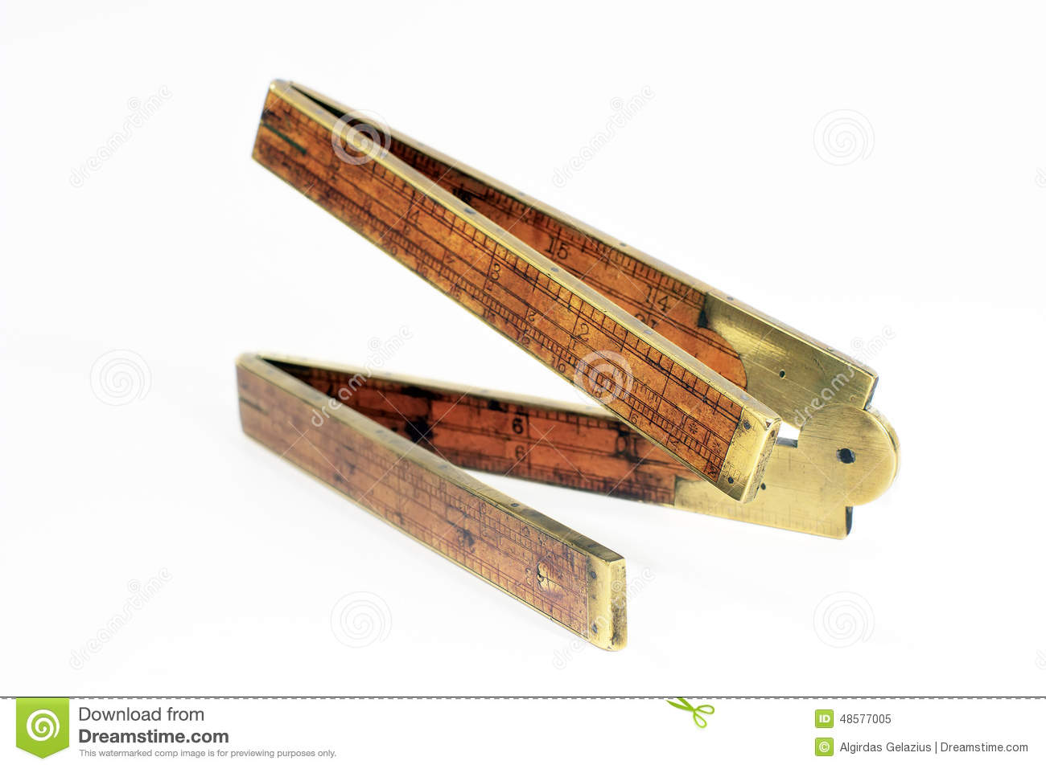
Category-
Specific tool-
Similarities-
Differences-
Tool name______________ Differences_____________________________________
Tool name______________ Differences_____________________________________
Tool name______________ Differences_____________________________________
Tool name______________ Differences_____________________________________
Tool name______________ Differences_____________________________________

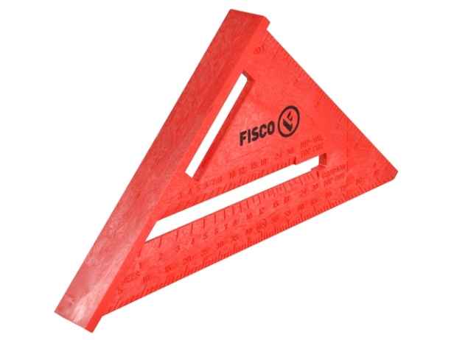
Category-
Specific tool-
Similarities-
Differences-
Tool name______________ Differences_____________________________________
Tool name______________ Differences_____________________________________
Tool name______________ Differences_____________________________________
Tool name______________ Differences_____________________________________
Tool name______________ Differences_____________________________________

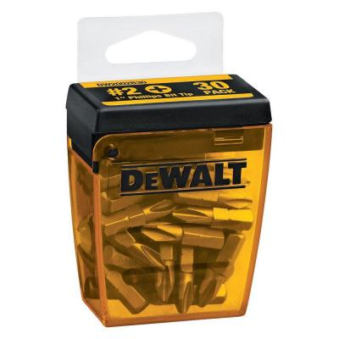
Category-
Specific tool-
Similarities-
Differences-
Tool name______________ Differences_____________________________________
Tool name______________ Differences_____________________________________
Tool name______________ Differences_____________________________________
Tool name______________ Differences_____________________________________
Tool name______________ Differences_____________________________________

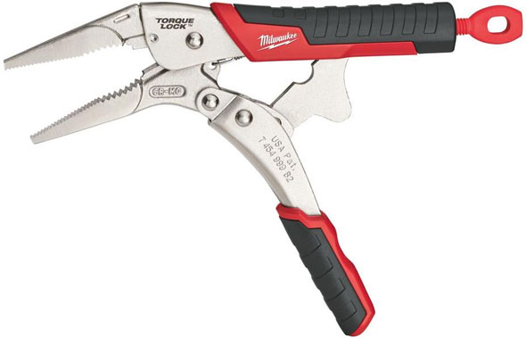
Category-
Specific tool-
Similarities-
Differences-
Tool name______________ Differences_____________________________________
Tool name______________ Differences_____________________________________
Tool name______________ Differences_____________________________________
Tool name______________ Differences_____________________________________
Tool name______________ Differences_____________________________________

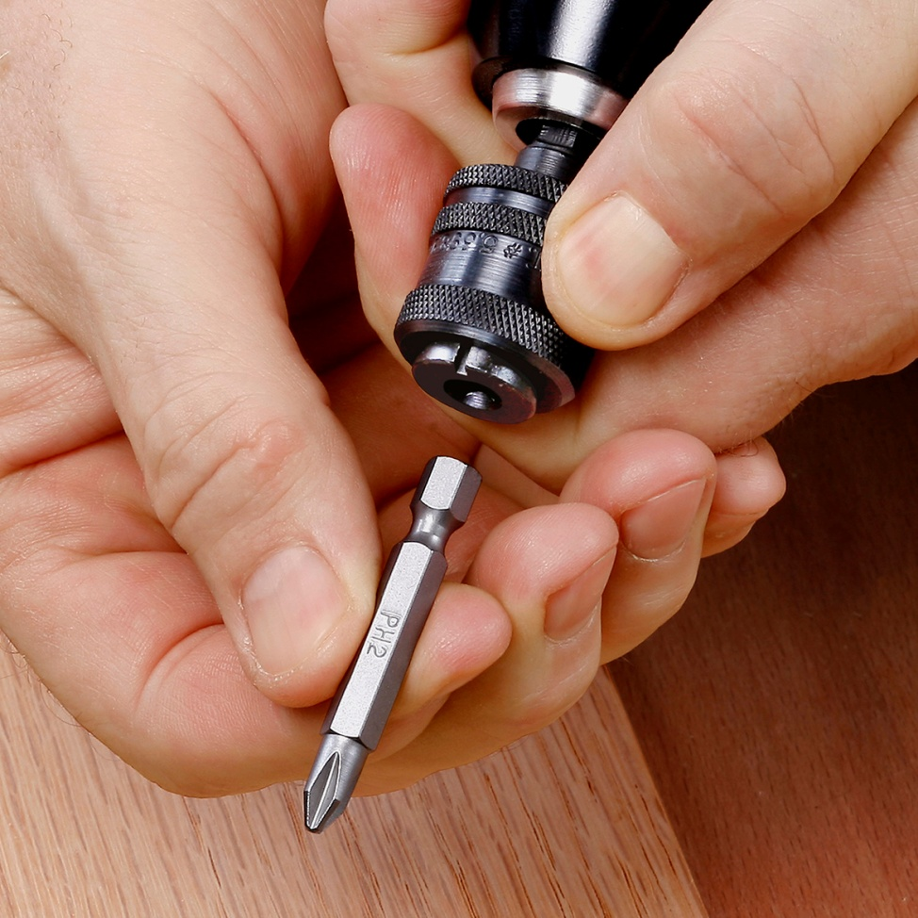

Category-
Specific tool-
Similarities-
Differences-
Tool name______________ Differences_____________________________________
Tool name______________ Differences_____________________________________
Tool name______________ Differences_____________________________________
Tool name______________ Differences_____________________________________
Tool name______________ Differences_____________________________________

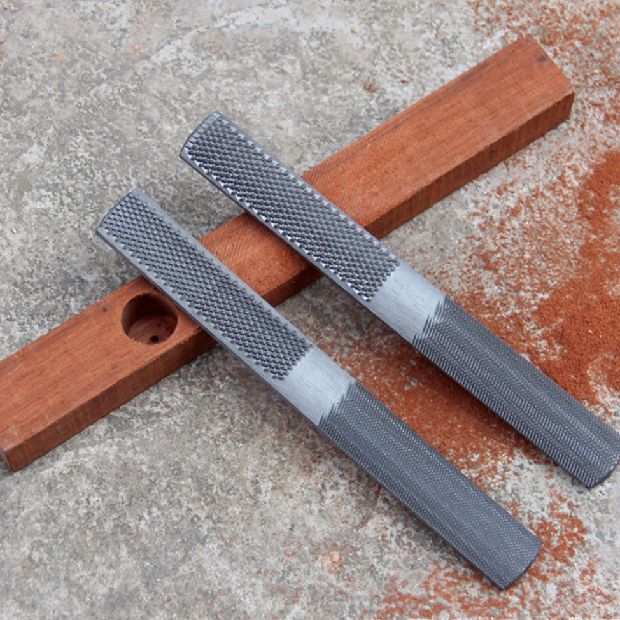
Category-
Specific tool-
Similarities-
Differences-
Tool name______________ Differences_____________________________________
Tool name______________ Differences_____________________________________
Tool name______________ Differences_____________________________________
Tool name______________ Differences_____________________________________
Tool name______________ Differences_____________________________________

